RUNNING HEAD: Domains of sequential decisions

Participants use a mixture of strategies to solve several domains of realistic image-based sequential decision problems

Didrika S. van de Wouw, Ryan T. McKay, Nicholas Furl

Royal Holloway, University of London

Corresponding author:

Nicholas Furl

Department of Psychology

Royal Holloway, University of London

Egham, TW20 0EX, United Kingdom

[Nicholas.furl@rhul.ac.uk](mailto:Nicholas.furl@rhul.ac.uk)

Data and code availability: <https://github.com/nicholasfurl/Model_fitting_imageTasks>

Abstract

Full-information best choice problems typify many real-world decisions. Participants face a sequence of decision options and must accept or reject each option at the time it is encountered. The challenge is to use prior knowledge of the distribution of option values to predict whether continued sampling might result in a higher-valued option than the one currently on offer. On these tasks, biases are apparent when human decisions are compared against mathematical optimality solutions. Specifically, tasks involving choices about options presented as images appear to evoke an oversampling bias, in which participants perform suboptimally by rejecting optimal choices and continuing to sample new ones. Using computational modelling of ten datasets spanning five choice domains, we demonstrate two dominant sampling strategies. These strategies involved a combination of overly optimistic predictions about future option values and an intrinsic perception that sampling itself has reward value. This pattern held when participants made overlong searches for the most attractive or trustworthy face image, and for searches for the best foods or holiday destinations. These strategies, and their associated systematic biases, could manifest in real-world decisions such as shopping, choosing dating partners or trustworthy job candidates.

Introduction

In many real-life situations, decision options appear in sequence and must be selected or rejected at the time of encounter. In the classic example of the “fiancé problem”, the astronomer Kepler allegedly interviewed multiple candidates for a new wife. When he proposed to one of them, he found himself duly rejected, as the chosen candidate did not appreciate that he had continued interviewing after first meeting her. Such decision problems have garnered considerable multidisciplinary interest. Mathematicians (cf. Ferguson, 1989) have identified means of calculating “optimal stopping” solutions (i.e., on which sample should an agent stop sampling options and commit to a choice?). The approach of comparing these mathematical optimality benchmarks against choice behaviour has been adopted within the behavioural sciences, such as in studies of mate choice in behavioural ecology (Castellano et al., 2012; Castellano & Cermelli, 2011) and economic choices in cognitive science (Baumann et al., 2020) and neuroscience (Costa & Averbeck, 2015).

We here consider perhaps the most generalisable and realistic version of optimal stopping problem: the full information problem (Lee, 2006). Consider a full information problem for hiring a new employee. The employer can use prior knowledge about the probability distribution that generates employees of varying quality (i.e., the generating distribution of option values). Then the employer interviews a known number of job candidates one at a time such that the quality of each candidate is revealed only at the time of interview. After each interview, the employer must decide whether to hire the candidate or reject them and interview a new one. Rejected candidates are quickly hired by competitors and so cannot be recalled for choice later sample a new option.

The current state-of-the-art ideal observer for the full information problem (Costa & Averbeck, 2015) is an evolution of the long-standing Gilbert and Mosteller (1966) solution. The ideal observer knows the mean and variance of a normally distributed prior on the potential option values. Then, using this generating distribution, the expected reward value of future samples if the agent were to continue sampling can be computed. This expected value functions as a varying choice threshold, which the current option value on offer must exceed to be chosen.

Although many previous studies of optimal stopping problems (e.g., Baumann et al., 2020; Cardinale et al., 2021; Costa & Averbeck, 2015; Goldstein et al., 2020; Guan & Lee, 2018; Guan & Stokes, 2020) asked participants to search for the best number (e.g., price), some recent work introduced an image-based full information problem. In Furl et al. (2019), participants attempted to sequentially reject face images before accepting the most attractive one they could. Interestingly, participants were biased toward sampling too many options, relative to the ideal observer. A subsequent study (van de Wouw et al., 2022) demonstrated oversampling for additional image-based domains: foods and vacation destinations. Here, we investigated hypothetical sources of this oversampling bias by fitting computational models to participants’ choice behaviour using ten datasets, including data from Furl et al. (2019), van de Wouw et al. (2022) plus three new datasets with new choice domains.

We build on previous approaches to modelling full information problems. Lee (2006) devised a model whose free parameters (estimated via fits to participant choice data) are the choice thresholds used at each sequence position. These models suggest humans use a linearly collapsing threshold (Baumann et al., 2020). Although such a modelling procedure would be useful for identifying how optimal and biased thresholds might differ, this formulation (within substantial addition) does not explicitly demonstrate the mechanism by which bias alters the thresholds. Here, we examined models that explicate the computational path connecting bias and the ensuing biased thresholds and sampling behaviour, and entered these models into formal model comparison for every dataset.

The first such model is the *cutoff heuristic* (CO) (Todd & Miller, 1999). CO is inspired by the optimal solution to a particular variety of optimal stopping problem, which is related to, but distinct from, the full information problem (Ferguson, 1986; Freeman, 1983). This “secretary problem” obtains a relatively elegant optimal solution, if one makes several assumptions, which are not satisfied by our full information tasks. We nevertheless consider this model here. Todd and Miller (1999) have proposed that people use heuristics, such that an easy-to-calculate solution that only approximates optimality would be psychologically plausible. CO learns its choice threshold from the earliest samples, prior to a cutoff sequence position, during which no choice is made (choice threshold is infinite). The optimal cutoff is 1/*e* ≈ 37% through the sequence. After the cutoff, the choice threshold becomes fixed at the best value observed so far. CO therefore modifies an optimal threshold computation (albeit for a slightly different problem) and parameterises this computation to introduce a hypothetical source of bias. We theorise that participants could oversample by employing a sub-optimally late cutoff.

For the other models we compared, we also modified an optimal computation – this time, the full information problem’s ideal observer (Costa & Averbeck, 2015) – and parameterised it to embody computational theories of oversampling. The *cost to sample model* (CS) considers that sampling might be intrinsically costly or rewarding. Indeed, the facial attractiveness task (Furl et al., 2019) resembles seemingly addictive dating apps like Tinder, in which users may enjoy considering sequences of face images. The Costa and Averbeck (2015) version of the ideal observer weights the prospective reward value of future samples by a “cost to sample” value (See Methods), which we treated as a free parameter in the CS model, under the hypothesis that apparent bias may arise from a perceived intrinsic reward value of sampling. We also parameterised this ideal observer to develop the *biased prior model* (BP). Here, the free parameter is a constant added to the mean of the prior generating distribution. Positive values of this parameter would bias the model to have overly optimistic expectations about future option values. In the Supplementary Materials, we describe two further models, which were excluded from model comparison as their parameters recovered poorly.

For all ten datasets, we fitted CO, CS and BP models and submitted them to formal model comparison. To anticipate our results: we replicated oversampling bias in all ten datasets. Participants’ sampling strategies across domains may be a mix of BP and CS strategies. These results offer a new computational theoretical framework for understanding choice, which may be relevant for predicting errors in real world sequential searches through images, such as in shopping contexts.

General Methods

Paradigm for all datasets

For all datasets, we measured participants’ preferences for the options in advance of the decision task by having them complete an initial rating task (phase 1), where participants viewed the entire “generating distribution” of images, each of which might or might not appear later as options in the decision task. Participants provided multiple ratings of each image for “attractiveness” and the separate ratings were averaged to obtain one stable subjective value estimate per image. We find average correlations across ratings of > .8 for all our datasets. We used these subjective value estimates in three ways, all of which allowed us to build bespoke models and measurements, tailored to each participant’s personalised preferences. First, we inputted as option values to our computational models the subjective values of the specific options that a corresponding participant received. Second, we programmed the mean and variance of that model’s generating distribution with the mean and variance of its corresponding participants’ subjective value distribution. As is described below, the model uses this distribution to predict upcoming option values. Third, we gauged the overall success of decision making by using each participant’s own subjective values to identify the rank of the chosen options, relative to other images in the same sequence.

Next, each participant and corresponding model engaged with several sequences of eight image options each, which were randomly sampled without replacement from the images in phase 1. In a given sequence, when an option was presented the agents decided whether to choose that option or, instead, reject it, rendering the option inaccessible and triggering the next option. Upon choice of an option, all remaining options became inaccessible, yet participants still needed to press a button to advance to the end of the sequence (remaining options were replaced by grey squares). Our existing data suggest that the presence of these grey squares do not affect participants’ sampling rates (van de Wouw et al., 2023). If an agent reached the final option in a sequence, that option automatically became the choice. A post-sequence feedback display showed the chosen image and solicited from the participant a rating of the reward value for this image. This rating activity only functioned to provide feedback to the participant and was not analysed.

Facial attractiveness dataset 1

Behavioural performance and demonstration of oversampling bias for this dataset was previously reported as Study 2 in Furl et al. (2019). The 20 participants were instructed that they would encounter face images of individuals interested in dating them and that their goal was to try to choose the most attractive dates possible. Participants opted to choose dates from either male or female faces. Participants in phase 1 rated 426 face images (Bainbridge et al., 2013) for facial attractiveness. Each image was rated three times on an integer scale from 1 to 9. After a brief distractor task, in which participants solved difficult arithmetic problems, they engaged with 28 optimal stopping sequences. For each participant, the paradigm generated a fresh random selection (without replacement) of sequence options from phase 1 for every sequence. The facial attractiveness dataset 1 paradigm was programmed in MATLAB R2020b (2010) using the COGENT 2000 toolbox http://www.vislab.ucl.ac.uk/cogent.php and data were collected in person in a laboratory setting.

Matchmaker dataset

Analysis of the matchmaker dataset has not been previously published. The paradigm was originally designed to test whether oversampling would replicate when facial attractiveness decisions were divorced from personal mate choice, where participants choose dates for themselves. To test whether participants change strategy when making mate choice decisions for others, we asked participants to imagine they were professional matchmakers and to choose the most attractive faces they could on behalf of a (fictitious) client, who has employed them to select suitable dates. Methods were identical to facial attractiveness dataset 1 aside from these instructions. We enrolled 20 participants (half women), who each chose which gender of face they would like to match for their client (five participants chose to rate female faces, the other 15 rated male faces). Data were collected in person in a laboratory setting.

Trustworthiness dataset 1

Analysis of trustworthiness dataset 1 has not been previously published. We attempted to replicate oversampling in a paradigm where the option values were still face images but the facial characteristic being maximised by choice was different from attractiveness. We chose a characteristic, trustworthiness, that seems relevant to real-world contexts, as decisions in contexts like courtrooms can be influenced by facial trustworthiness (Olivola et al., 2014). Participants chose a face gender for the task, as in the previous datasets. Then they rated faces in phase 1 for trustworthiness and subsequently, in the full information decision task, tried to choose the most trustworthy-appearing face they could. Methods were identical to those producing the face attractiveness dataset 1 and matchmaker datasets, except for these instructions. Most of the 20 participants were between 16 and 21 years of age (*N* = 19) and female (*N* = 18). Data were collected in person in a laboratory setting.

Trustworthiness dataset 2

Analysis of trustworthiness dataset 2 has not been previously published. This replication study aimed to validate the evidence for oversampling in our previous studies by obtaining an equivalent result of oversampling bias using a larger sample of participants with more data collected per participant. We enrolled from the online Prolific platform (Prolific, 2014) 64 participants between the ages of 18 and 35 years old from the majority English-speaking countries United Kingdom, Ireland, United States, Canada, Australia, and New Zealand. The paradigm was designed and hosted on the Gorilla Experiment Builder platform (Anwyl-Irvine et al., 2020). Participants in phase 1 chose whether they wanted to rate male or female faces and then rated the same images used in our previous studies for trustworthiness. Each image was rated three times, interspersed through the random sequence. Ratings were made using a 100-point sliding scale, where the slider position was initially hidden and only appeared when the participant made a selection via mouse click. The optimal stopping task immediately followed phase 1, without any intervening distractor task. In the optimal stopping task, participants attempted to choose the most trustworthy face possible in each sequence. Options were randomly sampled without replacement from the face identities rated in phase 1. Each of the 40 sequences used the same fixed order of options for every participant, although these fixed sequences were presented in a different random order for every participant. Options that remained unsampled in each sequence after choice were replaced by grey squares, which the participant needed to page through via button press. Upon sequence completion, a feedback screen was displayed, as already described for the datasets above.

Facial attractiveness dataset 2, foods dataset 1 and holidays dataset 1

These three datasets and their demonstrations of oversampling bias, relative to the ideal observer model, were previously reported in van de Wouw et al. (2022). They shared identical methods with trustworthiness dataset 2, apart from the following exceptions. Seventy-five participants per dataset were recruited from Prolific. Participants rated 90 images in phase 1 for “attractiveness”, each twice. They engaged with five sequences during the optimal stopping task. In facial attractiveness dataset 2, participants were instructed to choose the most attractive face that they could. In foods dataset 1, stimuli included photographs of prepared meals, taken from the image set described in Blechert et al. (2019). In holidays dataset 1, stimuli included images of popular holiday sites (e.g., the Eiffel Tower) taken from a royalty-free image database ([www.shutterstock.com](http://www.shutterstock.com)). For all datasets, participants were instructed to choose the most attractive option.

Facial attractiveness dataset 3, foods dataset 2 and holidays dataset 2

These three datasets demonstrated that oversampling replicates across the three image-based domains, a finding also reported in van de Wouw et al. (2022). The studies were respectively identical to facial attractiveness dataset 3, foods dataset 1 and holidays dataset 1, aside from the participant sample. Data were collected in-person on campus at Royal Holloway, University of London open days from prospective undergraduate candidates and their families. There were 32 participants in facial attractiveness dataset 3, 28 in foods dataset 2, and 36 in holidays dataset 2.

Ideal observer optimality model

The ideal observer used here is a discrete-time finite-horizon Markov process (Cardinale et al., 2021; Costa & Averbeck, 2015; Furl et al., 2019; van de Wouw et al., 2022). It computes a utility *u* for states *s* at samples *t*, which is taken as the maximal action value, out of available actions *a*. *u* depends in part on the integral over possible future states, weighted by the probability of transitioning into them from the current state This latter term therefore is computed based on the generating distribution, described above. The model uses backwards induction to derive utility values for the case where the agent chooses to sample again. See Baumann et al. (2020) for an intuitive description of this computation.

*u* also depends on the reward to be obtained for *a*. If the agent chooses to decline and sample another option, then merely equals *C*, the cost to sample. For all ten datasets, *C* = 0 in the ideal observer, as we never extrinsically rewarded or penalised participants for sampling. However, if the agent chooses one of the options, then the term in the above formula instead depends on the function *R*, which maps each option’s relative rank *h* onto its reward value.

As participants were instructed to choose the best options they could, the ideal observer model’s choices were always rewarded according to the value of the chosen option.

The ideal observer’s generating distribution, before any options are sampled, is assigned a prior mean *μ0*, degrees of freedom *κ* for that prior mean, a prior variance *σ*20, and degrees of freedom *ν* for that prior variance. *μ0* and *σ*20 were fixed to the mean and variance of the phase 1 rating distribution. The ideal observer then uses Bayes rule to update *μ0* and *σ*20 upon experiencing each new option value in each sequence.

Fitted models

A theoretically motivated free parameter was fit for each model. For CO, we fit the cutoff value, initialised it to the optimal cutoff value for the secretary problem (which equals 3 options for our 8 option sequences) and bounded it between two (to allow for a learning period of at least one option) and seven (to allow at least one option beyond the learning period to be available for choice). For CS, we fit the cost to sample, initialised it to its optimal value 0 and bounded it between -100 and 100. For BP, we fit a constant added to the prior mean *μ0*, which was initialised to the optimal value of 0 and bounded between -100 and 100. All models additionally included the Softmax inverse temperature parameter *β* as a free parameter. During fitting, *β* had an initial value of 1 and was bounded 0 to 200. Quality of model fit, in the form of the negative log likelihood, summed over each participants’ choices, was derived using probabilities computed from action values passed through the Softmax function. We used fminsearchbnd.m in MATLAB (Mathworks, Natick MA) for fitting. Parameter recovery is reported in the Supplementary Materials. We computed two metrics for purposes of model comparison. First, we submitted individual participant Bayesian information criterion (BIC) values to Bayesian *t*-tests to test pairs of models. Second, we determined which model had the best BIC for the most participants.

Transparency and Openness

All the datasets and analysis code that reproduces the figures can be found at <https://github.com/nicholasfurl/Model_fitting_imageTasks>.

Results

The columns of Figure 1 show Bayesian *t*-test analyses of the datasets where participants search for attractive faces as dates for themselves: facial attractiveness datasets 1, 2 and 3. All three datasets replicate robust oversampling by participants, relative to the ideal observer, as previously reported (Furl et al., 2019, van de Wouw et al., 2022) (Figure 1, top row, black and grey bars and points). All three datasets also suggest contributions of both CS and BP strategies. Both CS and BP, once fitted to behavioural data, approximate participants’ sampling rates, though the CO model underestimates these (Figure 1, top row). CS and BP BIC values are statistically better than CO values in all three datasets, though there is little evidence for any statistical differences between CS and BP (Figure 1, middle row). CS and BP are the best-fitting models for a considerable fraction of participants in all three datasets, with the two models accounting for roughly half the participants in facial attractiveness datasets 1 and 3 and a relatively clearer advantage for BP in facial attractiveness dataset 2 (40 participants for BP versus 25 for CS). Additional analysis of these datasets, including ranks of chosen items and model parameter estimates, is shown in Supplementary Figure S4.

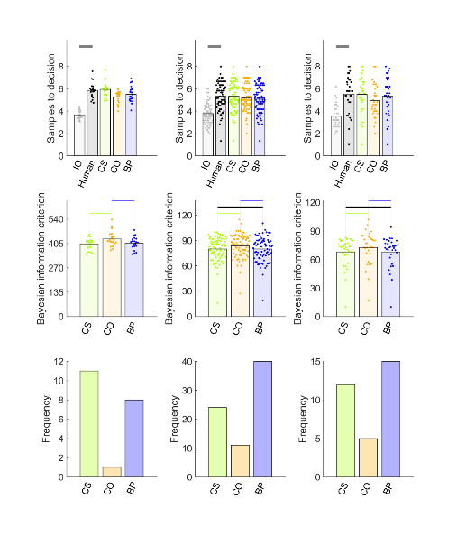

Figure 1. Human performance and model comparison for facial attractiveness datasets 1 (left column), 2 (centre column) and 3 (right column). Points in the first and second rows show data corresponding to individual participants, while bars show their mean values. In the first row, human and IO bars are demarcated by grey lines when *BF10* > 3 (moderate evidence for different means). Human and IO never showed *BF01* > 3 (moderate evidence for equal means). The second row shows BIC values (lower values indicate better model fit) for participants (points) and their mean values (bars). Black horizontal lines indicate when *BF01* > 3. When *BF10* > 3, the horizontal line is coloured the same as the bar of the better model. The third row demonstrates that BP tends to fit the most participants’ data overall, though CS accounts for many participants. Abbreviations: IO = ideal observer, CS = cost to sample, CO = cutoff, BP = biased prior.

Figure 2 shows results for the three datasets that involved decisions about facial stimuli but were not searches for the most attractive face for oneself. We replicate robust oversampling for all three datasets, matchmaker, trustworthiness 1 and trustworthiness 2 (Figure 2, top row, black and grey bars and points). These three new datasets show some differences from the datasets in Figure 1, as CS appears to make a stronger contribution than BP. In matchmaker dataset and trustworthiness dataset 2, CS shows statistically significantly better BIC scores than both BP and CO (Figure 2, middle row). CS further “wins” more participants than BP in all three datasets. Additional analysis of these datasets, including ranks of chosen items and model parameter estimates, is shown in Supplementary Figure S5.

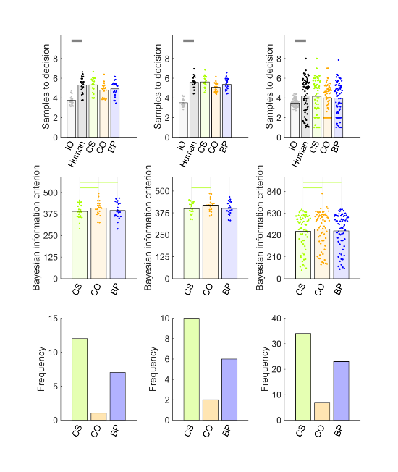

Figure 2. Human performance and model comparison for matchmaker dataset (left column), trustworthiness dataset 1 (centre column) and trustworthiness dataset 2 (right column). Points in the first and second rows show sampling corresponding to individual participants, while bars show their mean values. In the first row, human and IO bars are demarcated by grey lines when *BF10* > 3 (moderate evidence for different means). The second row shows BIC values (lower values indicate better model fit) for participants (points) and their mean values (bars). Black horizontal lines indicate when *BF01* > 3. When *BF10* > 3, the horizontal line is coloured the same as the bar of the better model. The green lines suggest that CS tends to fit significantly better than other models. The third row demonstrates that CS tends to fit the most participants’ data in all three datasets, though BP also accounts for many participants. Abbreviations: IO = ideal observer, CS = cost to sample, CO = cutoff, BP = biased prior.

Figure 3 shows data for the datasets involving non-face image stimuli: foods and holiday destinations. The top row reproduces the results from van de Wouw et al. (2022) that all four datasets replicate robust oversampling. The middle and lower row of Figure 3 shows that three of the four datasets – foods dataset 1, foods dataset 2 and holidays dataset 1 – show contributions of both CS and BP models. For these datasets CS and BP both show significantly better BIC scores than CO, with no evidence for statistical differences between CS and BP (middle row, Figure 3). Both of the foods datasets agree with each other that BP best-fits somewhat more participants (~5) than CS. The data for holidays is more inconsistent, as BP best-fits the most participants in holidays dataset 1 while CS best-fits the most participants in holidays dataset 2. We suspect this disagreement comes about because both strategies contribute when the domain is holiday destinations. Additional analysis of these datasets, including ranks of chosen items and model parameter estimates, is shown in Supplementary Figure S6.

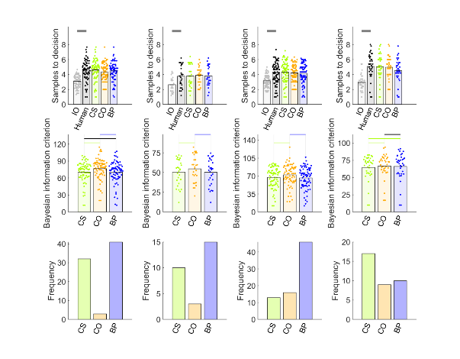

Figure 3. Human performance and model comparison for (columns from left to right): foods datasets 1 and 2, holidays datasets 1 and 2. Points in the first and second rows show sampling corresponding to individual participants, while bars show their mean values. In the first row, human and IO bars are demarcated by grey lines when *BF10* > 3 (moderate evidence for different means). The second row shows BIC values (lower values indicate better model fit) for participants (points) and their mean values (bars). Black horizontal lines indicate when *BF01* > 3. When *BF10* > 3, the horizontal line is coloured the same as the bar of the better model. The green lines suggest that, for both foods and holidays domains, CS and BP strategies are both strong contributors. Abbreviations: IO = ideal observer, CS = cost to sample, CO = cutoff, BP = biased prior.

Discussion

We built new computational theories to explain biased oversampling in image-based full information optimal stopping problems. These theories were tested against ten datasets of participant choices in a formal model comparison. We did not find one dominant model for all datasets. It seems more likely that participants use multiple strategies, even within a specific domain (e.g., facial attractiveness), though the mixture of strategies may vary by domain. All datasets showed some contributions of BP and CS models. However, evidence seemed to favour BP over CS to some degree for searches for attractive dates for oneself and for foods, while the evidence favoured CS over BP for searches for faces with other characteristics (attractive dates for another or trustworthy-appearing faces), and the evidence was more ambiguous for holiday destinations. We can reject the CO heuristic in favour of parameterised versions of the full information optimal solution like CS and BP. We also designed two more new computational theories BV and BR but needed to reject them based on poor parameter recovery (See Supplementary Materials).

Our technique for parameterising the optimality models of the secretary problem (CO heuristic) and the full information problem (CS and BP models) allowed us to simultaneously explain how participants can be mostly accurate and still have that accuracy tempered by different types of systematic error. Indeed, participants’ ranks of chosen options (Figures S4-S6) show that, across datasets, participants achieve their second or third favourite options in each sequence on average, even if they are held back from achieving more by their proclivity to continue sampling past more highly ranked options.

The models we consider here have an advantage over other approaches (e.g., Lee, 2006; Baumann et al., 2020) in that that they more completely specify how choice thresholds are computed for each option (i.e., the expected reward value of continued sampling, in the case of CS and BP) and allow the research to test how different sources of bias might affect these computations. Nevertheless, our models still treat these influences of bias as external to the model – estimating the source of bias from participant behaviour rather than explicitly modelling the reasons for the biases themselves. In other words, the reasons why participants might perceive a different reward value for sampling (CS model) or have overoptimistic expectations about forthcoming options remain the next steps for future research.

We might speculate, in the case of participants whose behaviour is best explained by CS, that sampling through and viewing many appealing and interesting images such as faces, foods or holiday destinations has its own reward value, beyond just the achievement of a high-quality choice, a reward value that is less present when participants must engage with numbers. Although there was on the whole somewhat more evidence for participants’ use of the BP strategy, the reasons that participants might use a BP strategy seem less obvious. The solution may lie in how the prior distribution is learned by participants. For example, participants may selectively remember high quality options that they hope to select later while forgetting less interesting options. This ensuing skewed memory of the option distribution could be learned either from encountering stimuli (e.g., faces) in the outside world before the study or during exposure to the generating distribution in phase 1. We note, though, that our preliminary results suggest that the presence or absence of a phase 1 does not affect sampling rates at least on economic full information tasks (van de Wouw et al., 2023). We recommend that future studies concentrate on examining how participants form expectations about reward from statistical distribution learning and to test whether optimistic prior expectations about images might arise in contexts more generally than just optimal stopping problems.

Our results, especially the robust finding of oversampling bias, were remarkably consistent across what amount to rather diverse datasets. Though the core methods embodying image-based full information problems were always present, the paradigm details markedly varied. Perhaps most importantly, the tasks varied by domain. Our preliminary hypothesis, based on oversampling in facial attractiveness tasks (Furl et al., 2019), was that oversampling arises from a predisposition to use a high threshold when choosing mates, a phenomenon claimed to hold for animals by the behavioural ecology literature (Valone et al., 1996). This preliminary hypothesis proves false. Instead, oversampling is a broader phenomenon that generalises beyond personal mate choice and extends to mate choices for others (matchmaker dataset), other judgments about faces (trustworthiness datasets 1 and 2) and beyond options presented as faces altogether (foods datasets 1 and 2 and holidays datasets). Interestingly, the oversampling bias we replicated multiple times herein frequently does not arise for full information tasks (e.g., Baumann et al., 2020) or secretary problem tasks (e.g., Seale & Rappoport, 1997) where participants must search through numbers for the best one (e.g., prices in economic domains). We suspect that it is the image-based nature of the option value presentation that, at least in part, instigates this oversampling bias.

In addition to the searches involving different domains, the ten datasets also vary in whether they were conducted in-lab, sampled from a mostly student population (facial attractiveness dataset 1, matchmaker and trustworthiness dataset 1), or online, sampled from a Prolific population (trustworthiness dataset 2, facial attractiveness dataset 2, foods dataset 1, holidays dataset 1) or in-person sampled from university open day attendees (facial attractiveness dataset 3, foods dataset 2, holidays dataset 2). The datasets also varied in sample size from 20 (facial attractiveness dataset 1, matchmaker dataset and trustworthiness dataset 1) to 75 (Facial attractiveness dataset 2, foods dataset 1 and holidays dataset 1). The number of sequences per participants varied from only five (Facial attractiveness datasets 2 and 3, foods datasets 1 and 2 and holidays datasets 1 and 2) to 40 (trustworthiness dataset 2). There was also no systematic relationship between the best-fitting models and the number of times potential options were rated in phase 1 or whether there was an intervening distractor task between phase 1 and the full information decision task. We note however that our first three studies (facial attractiveness dataset 1, matchmaker dataset and trustworthiness dataset 1) all used the same methods, sample sizes and (mainly student) participant populations and these were the datasets that showed a slight advantage for CS over BP. Perhaps student populations are relatively more susceptible to the reward value of sampling facial stimuli (as with dating apps like Tinder). Following on from our demonstration that oversampling might constitute a mix of different strategies, a fruitful line of research might be to confirm whether different populations are more or less likely to use a mixture of strategies.

In sum, our study demonstrates the utility of a modelling-based approach. We show here that more than one computational strategy (e.g., CS and BP) can give rise to the same apparent behavioural effect – oversampling. Moreover, fitting parameterised models can help identify individuals disposed to use these different strategies. Here, we use this approach to show (a) how oversampling generalises across several image-based choice domains; (b) the use of both CS and BP strategies in these domains; and (c) how to identify participants using each strategy. With increasing use of online and smartphone applications, from ordering a meal online to choosing a date on Tinder, more and more decisions are made by accepting and rejecting sequences of images. By studying these types of searches, providers and users of services involving such searches can better understand and perhaps even improve the performance of searches in real world settings like these.

References

Anwyl-Irvine, A. L., Massonnié, J., Flitton, A., Kirkham, N., & Evershed, J. K. (2020). Gorilla in our midst: An online behavioral experiment builder. *Behavior Research Methods 52,* 388–407. <https://doi.org/10.3758/s13428-019-01237-x>

Baumann, C., Singmann, H., Gershman, S. J., & von Helversen, B. (2020). A linear threshold model for optimal stopping behavior. *Proceedings of the National Academy of Sciences 117,* 12750–12755. <https://doi.org/10.1073/pnas.2002312117>

Bainbridge, W. A., Isola, P., & Oliva, A. (2013). The intrinsic memorability of face photographs. *Journal of Experimental Psychology: General 142,* 1323–1334. <https://doi.org/10.1037/a0033872>

Blechert, J., Lender, A., Polk, S., Busch, N. A., & Ohla, K. (2019). Food-Pics_Extended — An Image Database for Experimental Research on Eating and Appetite: Additional Images, Normative Ratings and an Updated Review. *Frontiers in Psychology, 10,* 307. <https://doi.org/10.3389/fpsyg.2019.00307>

Cardinale, E. M., Pagliaccio, D., Swetlitz, C., Grassie, H., Abend, R., Costa, V., Averbeck, B. B., Brotman, M. A., Pine, D. S., Leibenluft, E., & Kircanski, K. (2021). Deliberative choice strategies in youths: Relevance to transdiagnostic anxiety symptoms. *Clinical Psychological Science*, 1–11. <https://doi.org/10.1177/2167702621991805>

Castellano, S., Cadeddu, G., & Cermelli, P. (2012). Computational mate choice: Theory and empirical evidence. *Behavioural Processes, 90,* 261–277. <https://doi.org/10.1016/j.beproc.2012.02.010>

Castellano, S., & Cermelli, P. (2011). Sampling and assessment accuracy in mate choice: A random-walk model of information processing in mating decision. *Journal of Theoretical Biology, 274,* 161–169. <https://doi.org/10.1016/j.jtbi.2011.01.001>

Costa, V. D, & Averbeck, B. B. (2015). Frontal-parietal and limbic-striatal activity underlies information sampling in the best choice problem. *Cerebral Cortex* *25,* 972–982. <https://doi.org/10.1093/cercor/bht286>.

Ferguson, T. S. (1989). Who solved the secretary problem? *Statistical Science 4*, 282–289. <https://doi.org/10.1214/ss/1177012493>

Freeman, P. R. (1983). The secretary problem and its extensions: A review. *International Statistical Review / Revue Internationale de Statistique 51*, 189–206. <https://doi.org/10.2307/1402748>

Furl, N., Averbeck, B. B., & McKay, R. T. (2019). Looking for Mr(s) Right: Decision bias can prevent us from finding the most attractive face. *Cognitive Psychology 111,* 1–14. <https://doi.org/10.1016/j.cogpsych.2019.02.002>

Gilbert, J. P., & Mosteller, F. (1966). Recognizing the maximum of a sequence. *Journal of the American Statistical Association 61*, 35–73. <https://doi.org/10.2307/2283044>

Goldstein, D. G., McAfee, R. P., Suri, S., & Wright, J. R. (2020). Learning When to Stop Searching. *Management Science 66,* 1375–1394. <https://doi.org/10.1287/mnsc.2018.3245>

Guan, M., & Lee, M. D. (2018). The effect of goals and environments on human performance in optimal stopping problems. *Decision 5,* 339–361. <https://doi.org/10.1037/dec0000081>

Guan, M., & Stokes, R. (2020). A cognitive modeling analysis of risk in sequential choice tasks. Judgment and Decision Making 15, 823–850.

Lee, M. D. (2006). A hierarchical Bayesian model of human decision-making on an optimal stopping problem. *Cognitive Science 30,* 1–26. <https://doi.org/10.1207/s15516709cog0000_69>

MATLAB. (2010). version 9.9.0 (R2020b). Natick, Massachusetts: The MathWorks Inc.

Olivola, C.Y., Funk, F. & Todorov, A. (2014). Social attributions from faces bias human choices. *Trends in Cognitive Sciences 11,* 566-570. <https://doi.org/10.1016/j.tics.2014.09.007>

Prolific. (2014). Available at: <https://www.prolific.co>

Seale, D. A., & Rapoport, A. (1997). Sequential decision making with relative ranks: An experimental investigation of the "secretary problem". *Organizational Behavior and Human Decision Processes, 69,* 221–236. <https://doi.org/10.1006/obhd.1997.2683>

Valone, T.J., Nordell, S.E., Giraldeau, L-A. & Templeton, J.J. (1996). The empirical question of thresholds and mechanisms of mate choice. *Evolutionary Ecology 10,* 447-455. <https://doi.org/10.1007/BF01237729>

van de Wouw, S., McKay, R., Averbeck, B. J., & Furl, N. (2022). Explaining human sampling rates across different decision domains. *Judgment and Decision Making* *17*, 487-512. <https://doi.org/10.1017/S1930297500003557>

van de Wouw, S., McKay, R. & Furl, N. (2023). Perceived cost of sampling new options predicts decision biases in economic contexts. *PsyArxiv*. <https://doi.org/10.31234/osf.io/5j74d>

Supplementary Materials

Parameter Recovery

We tested whether parameters could be accurately recovered from our models. We configured theoretical parameters and produced simulated choices for the cutoff (CO), cost to sample (CS), biased prior (BP) and two other models, the biased values (BV) and biased rewards (BR) models (described below). We simulated data for 12 configured parameter values (The x axis of Figure S1 and the bar heights in Figure S2, upper panel, show these values), chosen to give rise as close as possible to the entire span of sampling rates (Figure S2 upper panel and Figure S3 x axes show the span of these simulated sampling rates). For each configured parameter value, we simulated a sample of 20 “participants” (about the same sample size of one of the smaller *N* datasets examined herein). For each simulated participant, a participant-specific generating distribution was created by sampling 426 values (the same number of phase 1 items in many of the studies herein) from a normal distribution bounded between 1 and 100 with a mean of 40 and a standard deviation of 20 (which roughly approximates the moments of participants’ empirical phase 1 ratings distributions). Then, five sequences (the smallest number of sequences per participant of the datasets examined herein) of 8 option values each were populated by sampling without replacement from each simulated participant’s individual generating distribution. The mean and standard deviation of each participant’s generating distribution were used to define the prior generating distribution in both the configured parameter models and the fitted models. The corresponding model was then fitted to these simulated data and the estimated parameter and its associated sampling rate were compared with the original configured parameter and its associated sampling rate.

The fitted CO, CS and BP models roughly reproduced the sampling rates (see Figure S2, middle panel) of their preconfigured counterparts (Figure S2, upper panel). The BV and BR models however appear unable to achieve sampling rates higher than about four. Individual participant sampling rates associated with configured and estimated parameters correlated well for CS, CO and BP but less so for BV and BR (Figure S3). Correlations of configured and estimated parameters were nearly perfect for CS and BP and tolerable for CO, though they were quite low for BV and BR (Figure S1).

Because BV and BR showed relatively low correlations between configured and estimated parameters, they were excluded from the formal model comparison reported in the Results. Descriptions of the models that were retained for further analysis, CS, CO and BP, are provided in the Introduction and Methods. Here, we briefly describe the two models BV and BR that were rejected based on the parameter recovery results. The *biased values model* (BV) transforms the option values before they are input to the ideal observer by setting option values below a threshold to 1 and above that threshold to 100. The threshold was the key theoretical free parameter. BV was motivated by “high threshold” models mat choice in behavioural ecology (Valone et al., 1996), where animals reject all potential mates only until encountering one with attractiveness above a high threshold. The threshold parameter was initialised to 50 and bounded between 1 and 100. The *biased rewards model* (BR) was based on the same idea as BV, except that the threshold transformation was applied to the reward values assigned to the relative ranks in each sequence. Option values above the parameterised threshold value were assigned a reward value of 100 and values below that threshold were assigned a reward value of 0. The threshold parameter was initialised to 50 and bounded between 1 and 100.

Figure S1. We examined parameter values (vertical axes) estimated from fitting models to decisions simulated using configured parameter values (horizontal axes) for 20 simulated participants (each shown as an individual scatter point) per simulated parameter level. The grey diagonal indicates when configured and estimated parameters would be exactly equal. The coloured line indicates the regression line relating configured and estimated parameter values. BR and BV models showed too poor parameter recovery to be entered into formal model comparison. Abbreviations: CS = cost to sample, CO = cut-off, BP = biased prior, BV = biased values, BR = biased reward.

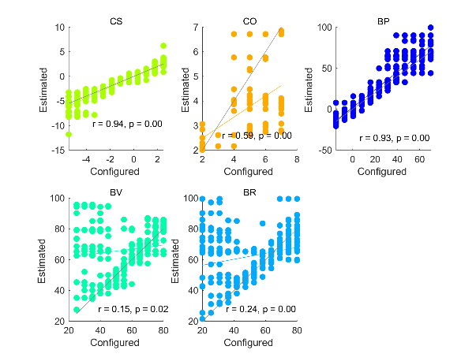

Figure S2. Top panel: We plot sampling rates for individual simulated participants (points) and their mean values (bars) for each configured parameter level in the parameter recovery analysis. Systematically varying configured parameter values successfully increases or decreases simulated sampling rates for CS, CO and BP. Middle panel: Models were fitted to the data in the top panel and parameters estimated. We plot the sampling rates simulated using each estimated parameter (points) and their mean sampling rates (bars). Lower panel: The estimated parameters (points) are plotted relative to their target configured parameter values (bars). Each model’s parameter values are normalised to a 0 to 1 range to facilitate plotting on one scale. Abbreviations: CS = cost to sample, CO = cut-off, BP = biased prior, BV = biased values, BR = biased reward.

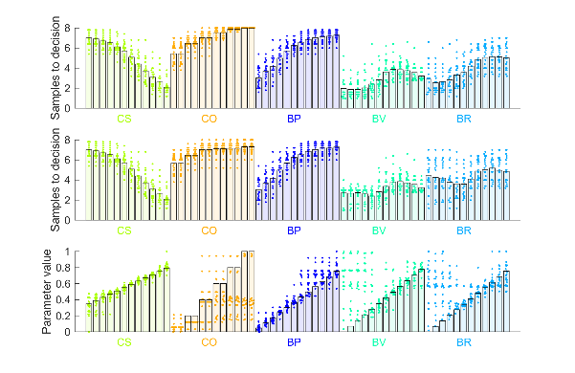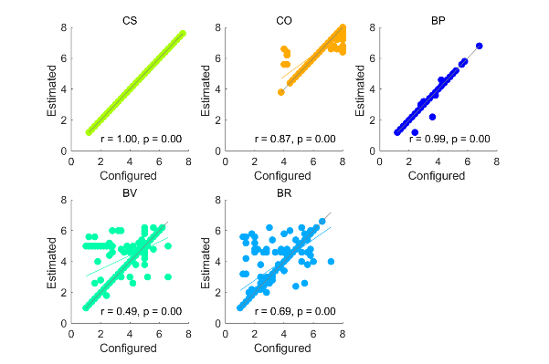

Figure S3. Sampling rates simulated using configured parameters (horizontal axis) are plotted against sampling rates computed from estimated parameters. The grey diagonal indicates when sampling rates based on configured and estimated parameters would be exactly equal. The coloured line indicates the regression line relating sampling rates based on configured and estimated parameter values. Abbreviations: CS = cost to sample, CO = cut-off, BP = biased prior, BV = biased values, BR = biased reward.

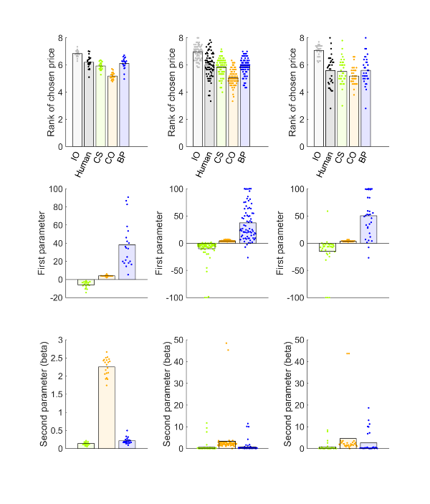

Figure S4. Model comparison for facial attractiveness datasets 1 (left column), 2 (centre column) and 3 (right column). Top and middle rows show data corresponding to individual participants as points and bars show their mean values. The top row shows the ranks of chosen items. The second row plots the “first” or key theoretical parameter values, estimated for each fitted model. The third row shows the “second”, or inverse temperature parameter beta, estimated for each fitted model. Abbreviations: IO = ideal observer, CS = cost to sample, CO = cutoff, BP = biased prior.

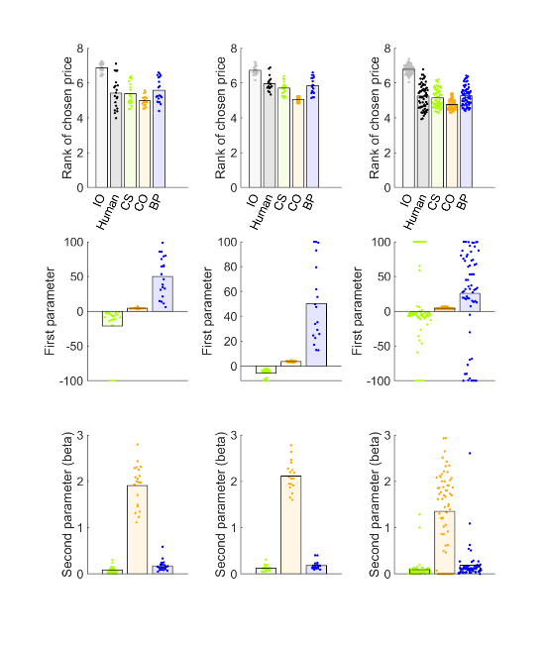

Figure S5. Model comparison for matchmaker dataset (left column), trustworthiness dataset 1 (centre column) and trustworthiness dataset 2 (right column). Top and middle rows show data corresponding to individual participants as points and bars show their mean values. The top row shows the ranks of chosen items. The second row plots the “first” or key theoretical parameter values, estimated for each fitted model. The third row shows the “second”, or inverse temperature parameter beta, estimated for each fitted model. Abbreviations: IO = ideal observer, CS = cost to sample, CO = cutoff, BP = biased prior.

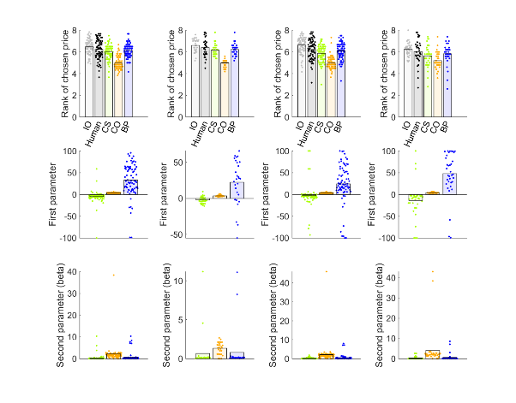

Figure S6. Model comparison (columns from left to right): foods datasets 1 and 2, holidays datasets 1 and 2. Top and middle rows show data corresponding to individual participants as points and bars show their mean values. The top row shows the ranks of chosen items. The second row plots the “first” or key theoretical parameter values, estimated for each fitted model. The third row shows the “second”, or inverse temperature parameter beta, estimated for each fitted model. Abbreviations: IO = ideal observer, CS = cost to sample, CO = cutoff, BP = biased prior.